Homework 2

## Requirements Elicitation

1. **What information is required for a student profile? Classes? Gender? Profile picture? Etc.?**
   1. Profiles shall show a student’s real name (no alias), a profile picture, optional short description, optional email and phone number, and optional media upload.
   2. Virtual badges given for participation shall be visible on student profiles.
2. **Will students have to use their school email to sign up for an account? How do they login on their accounts? Will there be Duo Mobile authentication required for login?**
   1. Students shall have to use their school email for login.
3. **Is Anteater Groups operating 24/7? Will it ever go offline for maintenance?**
   1. The app should be available 24/7.
   2. In the case that maintenance should be performed, it should be during a time where the app is used least (discussion among engineers).
   3. Go into maintenance once in two months or whenever there is a major break/critical issue.
4. **How many users is the application expected to support?**
   1. The app should support at least 10k users. (note: 30k students if all students participated)
   2. The app should keep in mind scalability.
5. **How will safety be ensured and inappropriate behaviors be addressed?**
   1. The app should detect inappropriate/abusive chat with machine learning algorithms, give the student a warning, then block students from using the application if behavior continues 2 or 3 more times.
   2. Students shall also have the ability to report other students if there is inappropriate behavior and the admin shall be able to review the report and take action.
   3. Reporting shall go to admins along with previous 4-5 chats where the user flagged as inappropriate.
6. **What personal information will be revealed to other students?**
   1. Information on student profiles
   2. Virtual Badges
7. **What information of usage or student data will be made available to administration?**
   1. A small snippet of chat (4-5 lines) that were reported to admins.
   2. Number of students logging in and registering.
   3. Data about performance, if groups are/aren’t performing well.
8. **If machine learning is implemented to track inappropriate language, how should the system behave in response to flags concerning poor mental health(ex. suicide) or threats? Should the wellness center or police be automatically notified?**
   1. Abusive/inappropriate behavior should be reported to the student safety council and the police if necessary.
9. **How will the app verify new members as UCI students?**
   1. UCI login access, duo mobile, OIT.
10. **How will student participation be measured?**
    1. Rewards are based on attendance.
       1. Example: yoga meditation, simple reward system, if the student has more than 50% attendance, he/she gets some reward which can be given by the person conducting yoga sessions.
11. **What are the ways to offer and award incentives to students? Do students get digital goods, physical goods, or reward points to be redeemed through the app or through a third-party partner?**
    1. Badges (bronze, silver, gold, etc) and Titles.
       1. Visible to other students on their ‘About Me’ section of their profiles.
       2. For identifying students’ shared interests.
    2. Digital goods and gifts can be sent from student to student.
12. **How will awards be fairly/randomly given to students who participate? Will winners be confirmed in-app and be required to verify their information online or in-person?**
    1. TBD.
13. **Who are allowed to create groups/events? Who gives admin level account status to students? How to manage duplicate groups/events?**
    1. Students are able to create public/private groups.
    2. Admin accounts can set groups/events as public (everyone can join) or private (request to join).
    3. All groups are visible to all students.
       1. Private groups are passcode secured.
       2. Public groups are open to join anytime.
14. **Will groups be pre-assigned to students based off of their year, major, etc. when they initially sign up?**
    1. Students shall be asked for their interests/likes/hobbies upon registration.
15. **In group posts, is there a character or word limit? Photo amount limit? Video length limit?**
    1. TBD.
16. **How small could a group be? (Minimum number of group members?)**
    1. TBD.
17. **Is there a maximum capacity of members per group, or does it depend on the type of group (i.e. group of students within a major vs. a club)?** 
    1. TBD.
18. **How is the group meeting area decided? Will all group members get to vote/ are areas predetermined based on availability/ number of participants?**
    1. TBD.
19. **Will students only be allowed to send text or will there be any file sharing option?**
    1. Similar to Facebook, they can add images or pdfs as well.
20. **What will be the main channels of communication, e.g. voice, text, video?**
    1. Voice chat, text chat, video chat / live streaming.
21. **How will users be able to connect to each other? Will there be options for them to search by name? Can they only see other users that share similar interests/courses/etc.?**
    1. Group members are visible.
    2. Mutual friends shall be suggested.
    3. TBD-search by name
22. **Will users be able to broadcast messages to other students to promote their campus events or activities?**
    1. Admins can promote.
    2. Students can be admins of groups they create and promote group activities
       1. Afraid of giving advertisement privilege to each and every student joining in. There might be a lot of noise / not a lot of precise advertisements.
23. **How will groups be promoted? Will there be categories as “Trending/Popular” or “Suggested” presented to the users?**
    1. Initial data with their interests from registration on the home page will be taken to show certain groups.
    2. There is an option to see all groups or top 10-15 interests/groups.
    3. There is an option to search for groups.
       1. Can search for a group using name or tag.
          1. Tags: category (sports), group names: specific (football, baseball etc)
       2. Can search by subjects.
       3. Should match keyword even if it isn’t exact (near match)
24. **Will students be able to ‘follow’ each other by confirming on both ends, or can a student connect with another student without it being reciprocated?**
    1. Students can have friends.
    2. Once someone in a group is your friend, you can privately message them.
25. **Can students gain administrator access to groups to manage and send announcements in the groups?**
    1. Yes, onboarded student admin shall have access to manage and send announcements in groups.
26. **Are faculty members allowed to join, and if so, can students connect with them like they do with their peers?**
    1. TBD.
27. **How can students report inappropriate behavior in groups?**
    1. There’s a report button to report certain chats and 4-5 previous chats will be sent along in the report for the admin to review.
28. **Where are the features and functionalities of the app on the screen? Group by category under different tabs? Or on a single page?**
    1. Admins can see how many students logging in/registering, how many students have created groups, on a centralized dashboard of single page
    2. Groups are visible on the home screen for students.
29. **Can Anteater groups adapt to tablets/iPads as well, and will the user interface be the same between both an Android operating system and iOS?**
    1. Make it as similar as possible for ease of use.
30. **Will there be accessible features, such as text to speech, screen magnifier, and more, for students with impairments or disabilities?**
    1. TBD.
31. **Where do meeting reservations, events dates, extracurricular appointments display on the app? Do they appear on third-party calendars like the Google calendar?**
    1. Under a separate tab or under the student’s profile category “schedule.”
    2. We can integrate Google Calendar for Google Reminders.
32. **Where would the participation history for each group meeting be stored? Under the group meeting history page, under student profile stats, or under the specific meeting?** 
    1. Under the student’s profile category “history.”
33. **Why the web-based subsystem to the Anteater Groups app ? Why don’t we have an interface for admin users on the same app or an app for admin users?**
    1. TBD.
    2. Decided from the case study, and giving them their own interface on the same or another app could be integrated later.
34. **How would you like navigation to be handled? Should a user be able to navigate from a homepage directly to private channels, or should they follow a hierarchical navigation (for ex. Home page -> groups -> group channels -> group meetings)?**
    1. TBD.
35. **Will this only be restricted to UCI students or will students from other campuses have access?**
    1. Only UCI students will be able to use Anteater Groups.
36. **Will there be an option to import planned meetings or events into the user’s native calendar application?**
    1. We can integrate Google Calendar for meetings.
37. **What is the process like when students first download the application and create a profile?**
    1. Students shall login with UCI netID, and then upon registration, they shall be asked questions about their interests to produce suggested groups and be able to make a profile with their name and other optional information.
    2. Borrow registration process from MeetUp.
38. **Will there be integration with third-party apps?**
    1. Google calendar may be integrated with the app.
    2. There may be a UCI map feature integrated.
39. **What privileges/permissions will UCI administration and wellness center staff have? Are they able to view chat channels, disable student accounts, create groups or events, etc.?**
    1. Admin shall be able to view student-made reports on inappropriate behavior and take further action, but to keep privacy, they do not have full access to groups/chat rooms.
40. **Will the wellness center staff and campus administration be able to track how many students view a group or event page?**
    1. Administration shall be able to view how many students are registered on the application, how many groups are created,
41. **Will announcements from campus wide emails overlap with announcements through Anteater Groups?**
    1. TBD.
42. **When do you plan to launch the app?**
    1. September 2022.
43. **When will a fully functional app need to be available?**
    1. TBD.
44. **What is the budget range that will be allocated for this application?**
    1. TBD.
45. **What is the expected deadline to have a mock up, prototype, minimum viable product, and final product?**
    1. A mock up version should be available in 1 month and 1 week.
    2. A prototype and MVP should be available in 3-6 months.
    3. The final product should be available by September 2022.
46. **How is the group meeting area decided? Will all group members get to vote/ are areas predetermined based on availability/ number of participants?**
    1. TBD.
47. **How will students be able to reserve locations? Will they have access to reserving classrooms or buildings when they are not in use for lectures and other school activities?**
    1. TBD.
48. **Will students need to verify their reservations when they show up at in-person events?**
    1. TBD.
49. **Will UCI keep track of attendance for on-campus events and activities?**
    1. TBD.
50. **Who will use this app the most?**
    1. UCI students are the main users of this app as the purpose of this app is to promote student connectivity.
51. **Who will use this app the least?**
    1. TBD.
    2. Alumni will not be able to use the app.
52. **Who will get reports on users’ interactions and violations?**
    1. The UCI administration will get reports.
    2. The UCI Police Department may be involved for certain violations.
53. **Who do students look for when having problems or technical issues with the app?**
    1. TBD.
54. **What other features besides creating and promoting connectedness and personal growth should the app have? Do students have the option to seek a mental health hotline or reach a specialist to address their mental health issues through the app?**
    1. TBD.
55. **Why is this app relevant in today’s post-COVID setting?**
    1. TBD.
56. **Will UCI alumnus be able to use the application or only current students?**
    1. Only current students should be able to use the app and alumni shall lose access.
57. **Are push notifications on by default?**
    1. Students should have control over it (turn on, off, selective).

# 

## Stakeholder Model

### Rich Picture

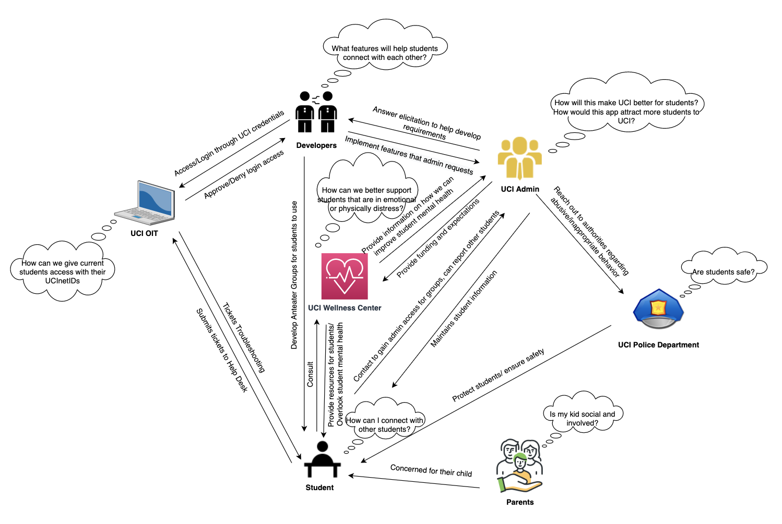

### Textual Stakeholder Analysis

* UCI Administration
  + Priority: High
  + Relation: The facilitator and approval committee overlooking the overall Anteater Groups project. Any expectations, requirements, and specifications are outlined by the UCI Administration. They are in partnership with the UCI Center for Student Wellness and Health Promotion and developers to create Anteater Groups.
  + Expertise: UCI Administration has full knowledge of the different groups on campus, including but not limited to schools (ex. Henry Samueli School of Engineering), clubs, support services, commissions, centers, offices (ex. Office of the Vice Provost for Research), and departments.
  + Primary Concern(s): Administration wants the app to be successful among students as they build a stronger community, and possibly improve the outlook of UCI to the rest of the world.
* UCI Center for Student Wellness and Health Promotion
  + Priority: High
  + Relation: The UCI Center for Student Wellness and Health Promotion is overlooking student mental health. They overlook student interaction and provide resources for students regarding wellness and strive for students to connect with one another. They want to work together with UCI Administration and developers to create Anteater Groups.
  + Expertise: The UCI Center for Student Wellness and Health Promotion are experts at mental health understanding. They understand it is difficult to connect with other students and make friends.
  + Primary Concern(s): They want students to improve their mental health through enhanced social connectedness and personal growth. They want students to learn and grow in their personal interests and overall engage more with their community.
* UCI OIT
  + Priority: Medium
  + Relation: UCI OIT manages students’ UCInetIDs that provide students with access to UCI online services. Students shall use these UCInetIDs to log into Anteater Groups. OIT is responsible for giving proper access to current UCI students and working together with developers to allow students to login.
  + Expertise: They are experts at information security and management. They know how to work with other team developers to integrate UCInetID logins onto other applications.
  + Primary Concern(s): They are concerned about properly providing access to Anteater Groups and associating students with their login information. Only current students and admins can use the app currently.
* UCI Students
  + Priority: High
  + Relation: The sole focus of the application is the students. Their needs and expectations are carefully considered in the designing and drafting of the Anteater Groups app. They can directly reach out to UCI Admin to report student behavior or ask for admin permissions, and can depend on the UCI Center for Student Wellness and Health Promotion to overlook their mental health.
  + Expertise: Beginner; Learning how to use the app and navigating through the app to grow their interests and find their relatable groups to join.
  + Primary Concern(s): Anteater Groups can address their issues or not.
* UCI Parents
  + Priority: Low
  + Relation: Parents and guardians of UCI students. Parents will want to make sure that their child is able to connect with others and join social groups that promote connectivity and help them to find their interests.
  + Expertise: Parents are knowledgeable about the wellbeing of their child and expect their school to properly take care of their children.
  + Primary Concern(s): Parents want to know how their child is doing in school.
* UCI Police Department
  + Priority: Medium
  + Relation: UCIPD addresses and investigates reported cases provided by UCI Administration on Anteater Groups if they require attention from law enforcement. They are the last in the chain to address student-reported issues on the application.
  + Expertise: The police department are experts in handling situations that deal with rules or the law. They are able to safely navigate dangerous situations and make sure that people are protected.
  + Primary Concern(s): The police would be concerned with the safety and well-being of students and administration. They would want to make sure that students who are not behaving appropriately will be monitored and have consequences for their actions.
* Developers
  + Priority: Medium
  + Relation: The software developers program all aspects of the application as well as address and fix any bugs found by students. They work together with the UCI Center for Student Wellness and Health Promotion and UCI Administration to develop the app that they want. The UCI Center for Student Wellness and Health Promotion and UCI Admins instruct the developers on how student interaction can be improved.
  + Expertise: The developers have the most knowledge on how the algorithm of Anteater Groups works, as well as the best frameworks and technologies to develop the app for optimal performance and meet specifications.
  + Primary Concern(s): They are concerned with implementing the right features that will satisfy the goals of Anteater Groups. They want to accurately document their customer’s needs, implement them, and provide a positive user experience for students and admins.